Kol simcha torah gazette
For parshas re’eh 5784
Volume 8 Issue 49 (Whole #409) 27 Menachem Av 5784/ August 31, 2024
Printed L’illuy nishmas Nechama bas R’ Noach, a”h

For a free subscription, please forward your request to keren18@juno.com
Past emails can be found on the website ShabbosStories.com under Brooklyn Torah Gazette

Massive Search Effort in Northern Arizona Locates Missing Jewish Child
By Mendel Super

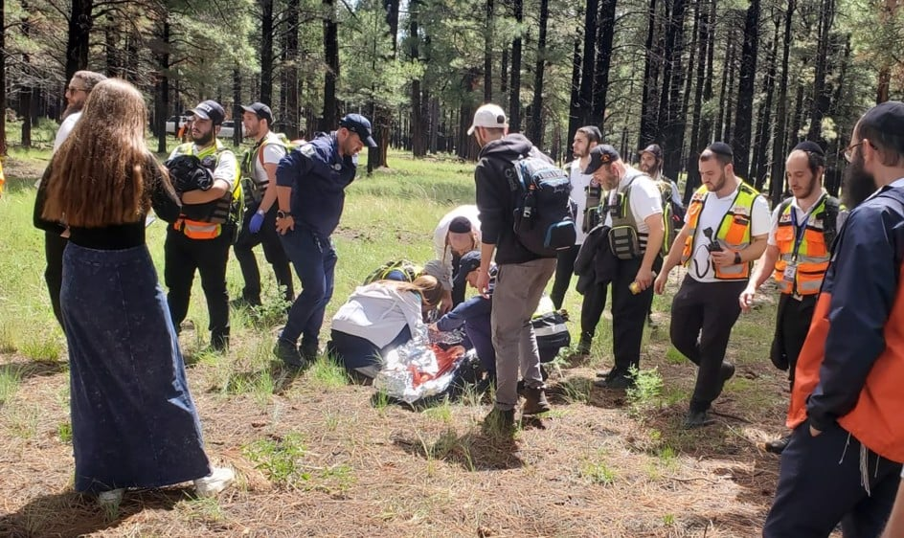
Within 90 minutes, Rockland Chaverim found the boy alive and stable.
Photo courtesy of Chabad-Lubavitch of Flagstaff
LAKE HAVASU CITY, Ariz.—Tzion Maron, an 8-year-old boy visiting northern Arizona with his family from Baltimore, went missing on Wednesday night at 6 p.m. as he and his family made their way out of Lava Cave, a popular subterranean trail in the Coconino National Forest just outside of Flagstaff, Ariz. “When they came out of the cave, the kid was gone—lost in the woods,” Rabbi Dovie Shapiro, director of Chabad-Lubavitch of Flagstaff, told Chabad.org.

The First to Get the Call from the Distraught Family
Shapiro was the first to get the call from the family of the boy, along with Chaverim of Arizona, a Scottsdale-based Jewish volunteer organization that renders assistance for anything from a flat tire to a search and rescue mission. Shapiro gathered community members of Chabad of Flagstaff who were familiar with the terrain and immediately began searching. “We were there all night doing as much as we could in the dark. The Coconino County Sheriff’s Search and Rescue team was also involved,” he says.
The team from Scottsdale arrived later that evening, headed by Moshe Lobl. “We collaborated, even though we were two hours away,” Lobl says. “Rabbi Shapiro mentioned bad weather, so we brought the necessary gear and people. Last night, we started searching. It was an amazing effort. Seeing how the rabbi went all out with food and accommodations was incredible.”
Hatzolah of Los Angeles, a Jewish medical first-responder volunteer organization sent a crew and a mobile command post as well. In what Shapiro describes as the “most amazing part” of the rescue effort, the New York-based Hatzolah Air flew in seasoned search and rescue professionals from Chaverim of Rockland County, N.Y., on a private plane. From nearby Sedona, Rabbi Mendel Kessler, director of Chabad of Sedona, also joined the search party.

Searched the Area with Drones at Daybreak
“When Rockland Chaverim arrived, their coordination and professionalism were unbelievable,” Shapiro says. They began searching the area with drones at daybreak, and employed crews on the ground at 9:30 a.m. By 10:45 a.m., Rockland Chaverim had found the boy just outside the first-priority search zone established by the sheriff’s department, alive and stable.
“Everyone worked together to make this happen. We were the first on the ground and stayed the whole time, serving as a link with the local sheriffs and SAR teams, and providing food for the SAR teams,” says Shapiro, noting how Chabad’s chef and kitchen staff went into overdrive preparing food for all the volunteers.
“Now, everyone is headed to Chabad for a celebration meal,” he adds.
“There was a massive amount of people and incredible speed involved,” says Lobl of the Arizona Chaverim branch. “It felt like it was my own son who was missing; I have an 8-year-old daughter, and I couldn’t leave until we found the boy.”
He says “the entire Flagstaff community—Jewish volunteers, non-Jewish volunteers, everyone came together. It was an amazing sight to see. Despite everything going on in the world today, it’s heartwarming to know there’s a place like Arizona where people are so friendly and giving. It was a real team effort.”

Reprinted from the August 22, 2024 website of Chabad.Org

Thoughts that Count
for Our Parsha

And you shall possess it and dwell in it (Deut. 11:31)
The very next verse continues: "And you shall take care to do all the statutes and judgments which I set before you this day." From this we learn that the mitzva to dwell in the Land of Israel is considered equal to all of the Torah's commandments. (Sifrei)

But when you go over the Jordan, and live in the land the L-rd your G-d gives you to inherit, and when He gives you rest from all your enemies around, so that you live in safety (Deut. 12:10)
At first glance this verse appears redundant. If G-d gives us rest from all our enemies, wouldn't we automatically enjoy security and protection? However, with these words the Torah is offering us surefire advice: If you want G-d to take care of all your enemies, make sure that "you live in safety" within your own camp. When Jews are united and cohesive rather than divided into separate factions and groups, they have nothing to fear from their adversaries, as our Sages said: "If Israel were one cohesive unit, no nation or tongue would have power over them." (Gelilei Zahav)

Reprinted from the Parashat Re’eh 5761/2001 edition of L’Chaim.

Rav Avigdor Miller on
How to Properly Utilize the
Upcoming Month of Elul

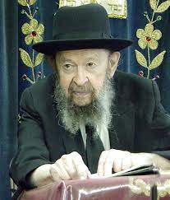

Elul is a great opportunity to prepare for the Yom Hadin. And how to prepare? First and foremost, to learn sifrei mussar. There’s no question that that is the method. Of course, if a person will stop putting on tefillin let’s say or stop saying kriyas shema because he wants to learn sifrei mussar, we understand that he’s frustrating what’s written in the seforim; but it means that as he continues doing all the things that he does – learning too – and he even does it better and he learns even more, he also adds the element of learning mussar seforim that’s how to utilize Elul.
It means learning Mesillas Yesharim – Mesillas Yesharim is tried and proven as one of the great influences in people's lives. It means learning also Shaarei Teshuva, especially the second and third shearim. Also learning Rambam Hilchos Teshuva.
Of course, if you’re fortunate enough to be in a yeshiva where they have shmuezen in mussar it’s very important to pay attention and take them to heart but sefarim of mussar are the most important ingredient that you could add to the month of Elul. Of course you won't do it. I'm just telling it to you just as a curiosity. Lema’aseh I know people won't listen to me but I'm saying it anyhow to answer your question: Elul is the month for meditation and for stirring up one’s mind with inyanei mussar.

Reprinted from a Parshas Re’eh 5784 email of Toras Avigdor (Tape #377 – August 1981).
Rabbi Berel Wein on
Parshat Re’eh 5784

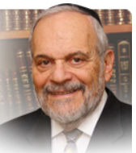

Moshe seemingly interrupts his long oration to the Jewish people about their history and destiny with a surprising review of the year’s calendar holidays. The calendar has always been central to Jewish life and survival. Under the dark regime of Stalin, Soviet Jewry was forbidden from owning or possessing a Jewish calendar.

The depths of loyalty of Soviet Jewry, to their inner faith, is seen in the fact that somehow millions of Soviet Jews still knew when the Jewish holidays would occur. For the calendar is the rhythm of our lives and evokes with it memory, hope and a feeling of the timelessness of Jewish life and its traditions.

A Threat to the Atheistic,
Cruel Communist Regime
As such, the mere existence of the Jewish calendar posed a threat to the atheistic, cruel Communist regime that ruled then over a large part of humankind. The calendar in Jewish life and thought does not really only mark the passage of time gone by. Rather, it focuses on time that is yet to come, on the future, which can somehow always be brighter than was the past.

One of my younger grandchildren proudly told me that he had calculated how many years in the future a certain anomaly on the Jewish calendar, regarding erev Pesach, would occur. I bless him that he lives to see it but he is already certainly enthusiastic about the prospect and looks forward to its happening. The calendar supplies us with a vision of the future and allows us the ability to feel that we are masters of our own fate and that we can, by our own efforts, be influential in determining our destiny.

The Jewish Calendar Still Remains
One of Upbeat Spirit and Joy
The Jewish calendar is a progression of one holy day to the next holy day. We are always on the way to celebrate and commemorate our obligations to serve our Creator. Though there have been numerous sad days introduced into our calendar since the times of Moshe, the Jewish calendar still remains one of upbeat spirit and joy, family and hospitality, compassion and appreciation of life and its bounties.

The parsha of Re’eh always falls in the month of Elul, leading to the glorious month of Tishrei with its days of awe and compassion and the celebration of Torah and its commandments on Succot. The review of the Jewish year, which occupies a great deal of the subject matter of this week’s parsha, is therefore most fitting for it prepares us not only for the coming month but for the coming year generally.

Reminding Us Daily of Our Uniqueness
as a People and the Eternity of Our Torah
Though the future is always inscrutable, we can nevertheless be comforted and feel secure by the consistency of our calendar, which has marked the journey of the Jewish people through time and centuries. The Jewish calendar reminds us daily of our uniqueness as a people and of the eternity of our Torah and our faith. It thus fits rather neatly into Moshe’s overall message to the Jewish people as recorded for us here in the book of Dvarim. The passage of time itself is one of the life’s gifts bestowed upon us by our Creator.

Shabat shalom

Reprinted from the current rabbiwein.com website.

Every Jew Must See G-d’s
Providence in All His Actions
From the Teachings of the Lubavitcher Rebbe
Rabbi Menachem Mendel Schneerson, Zt”l
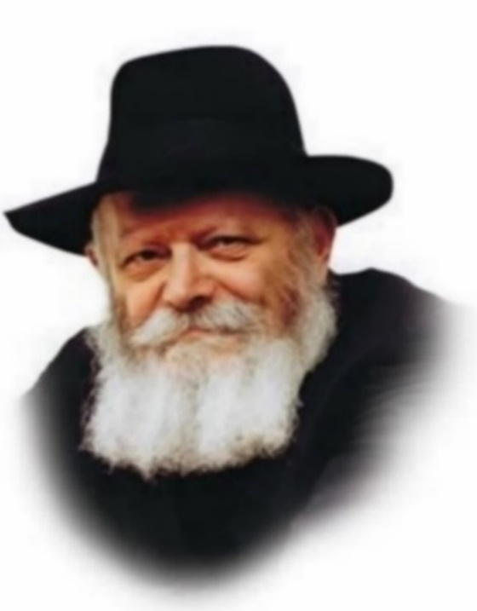
This week's Torah portion, Re'ei, touches upon numerous subjects, including the warning not to be involved with idolatrous practices, a list of kosher animals and non-kosher birds, the laws of tithes and a brief discussion of the three Pilgrimage Festivals.
The portion opens with the words: "See [re'ei], I set before you." G-d commanded Moses to convey to the Jewish people that they must consider and reflect on the holy words of Torah until they can actually "see" how G-d Himself takes care of each and every individual, great and small. G-d abandons all His other affairs, as it were, to provide every Jew with all his needs, "from His full, open, holy and broad hand."
It is not enough for a Jew to believe this on faith or understand it as an intellectual principle. A Jew must be able to "see" Divine Providence in the same way he can perceive a physical object with his fleshly eyes.
This, in fact, is the practical directive to be derived from this week's Torah reading, whose name "Re'ei" means "See":
Everything in Torah that a Jew learns should be "seen" rather than merely accepted or believed. In other words, a person should be so confident and sure of what he has learned that it is as if he can actually see it on the physical level.
This level of surety applies at all times and in all circumstances, whether it is "daytime" or "nighttime" in either the literal or symbolic sense. A Jew must always strive to see the G-dliness and holiness in all his actions.
Even before drinking a simple glass of water we make the blessing "Shehakol -Blessed are You, L-rd our G-d, King of the world, that everything came into being with His word." We address G-d directly, recognizing that everything in the world was created and exists only because of His will.
By accustoming ourselves to always look for G-d's hand in everything around us, we will merit to "see" the fulfillment of the verse at the end of the Torah portion:
"Three times a year shall all your males be seen before the L-rd your G-d in the place which He shall choose." Our daily prayers will be answered, "May the Holy Temple be rebuilt speedily in our days," and "May our eyes behold Your return to Zion in mercy," with the coming of Moshiach and the Final Redemption.

Reprinted from the Parashat Re’eh 5761/2001 edition of L’Chaim, a publication of the Lubavitch Youth Organization in Brooklyn. Adapted from the talks of the Lubavitcher Rebbe on 20 and 21 Menachem Av 5749, and 22 Menachem Av 5750.

Another Thought that
Counts for Our Parsha

And all your children shall be taught of the L-rd; and great shall be the peace of your children (Isaiah 54:13; from the haftorah)
The first Holy Temple was destroyed because the Jewish people did not keep the Torah's laws properly. The second Holy Temple was destroyed because of the sin of unwarranted hatred. The Prophet Isaiah, however, assures us that in the Messianic era, neither of these negative factors will affect the Third Holy Temple. "All your children shall be taught of the L-rd" - all Jews will be knowledgeable and observe the Torah; "and great shall be the peace of your children" - they will live together in harmony and brotherhood. (Afikei Yehuda)

Reprinted from the Parashat Re’eh 5761/2001 edition of L’Chaim.

“See, Anochi / I Present Before You Today a Blessing and a Curse.” (11:26)

R’ Yehuda Modern z”l (1819-1893; Rosh Yeshiva in Sighet, Hungary) writes: Earlier commentaries quote a Midrash stating that the word “Anochi” in this verse alludes to the first of the Ten Commandments: “Anochi / I am Hashem, your Elokim.”
However, the Midrash does not explain what the significance of this allusion is. It appears, R’ Modern writes, that the message of the Midrash is as follows: Our Sages teach that we are sustained in this world in the merit of our Emunah / faith. On the other hand, our Sages teach that we are not rewarded for our Mitzvot in this world; rather, the reward for our Mitzvot will be forthcoming in the World to Come.
But how can this be? Is there not a commandment in the Torah that a worker be paid on the same day that he worked? Thus, we should be rewarded for our Mitzvot the same day we perform them!
The answer, R’ Modern writes, is that there is an exception. Specifically, the Mitzvah to pay workers the same day does not apply if workers were hired through an agent. [The reasoning for that Halachah is beyond the scope of this space.] Since Hashem gave the Torah through an agent (Moshe), Hashem is not obligated to pay us for observing the Torah on the same day as our Mitzvah performance, and He can pay us in the World to Come instead.
However, R’ Modern continues, there are two Mitzvot which Hashem did teach us directly–the first two of the Ten Commandments, which our ancestors heard at Har Sinai directly from Hashem. For those Mitzvot, which encompass the commandment to have Emunah, Hashem must reward us in this world.
Hence our Sages’ teaching that we are sustained in this world in the merit of Emunah. “See,” says our verse, “because of Anochi I give you a blessing or curse today!” (Pri Ha’eitz)

Reprinted from this week’s email of R’ Yedidye Hirtenfeld’s whY I Matter parshasheet for the Young Israel of Midwood in Brooklyn.

The Unusual Second
Siyum of the Talmud
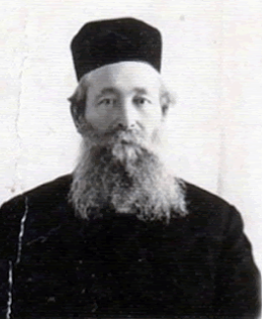
Rabbi Zelig Reuven Bengis

We have noted the importance of studying at fixed times. Of course, this does not mean that one should study only at those times, for as explained above, all times are good for Torah study. It is told that R' Zelig Reuven Bengis (1864-1953), the late Rabbi of Yerushalayim, made a regular "Siyum" - festive meal on the completion of the entire Talmud every six weeks - as he was constantly reviewing that work.
Once, however, he made two "Siyumim" within a span of two weeks, and this surprised his family. He explained,
"The present Siyum is for the special study of the Talmud that I undertook while waiting at weddings and doctors' offices."] (Hamaayan)

Reprinted from this week’s email of R’ Yedidye Hirtenfeld’s whY I Matter parshasheet for the Young Israel of Midwood in Brooklyn.

Antisemites Are
Attacking the Talmud
By Rabbi Efrem Goldberg



Influencers are shamelessly promoting blood libels and unfounded accusations about the Talmud to an audience eager to hear it. Arm yourself with knowledge.

This week, a Jew hater with 1.6 million Twitter followers posted an image consisting of a collection of supposed passages from the Talmud that paint Jews as disparaging towards and discriminating against non-Jews, seeing them as inferior and treating them with a bias and double standard. The image isn’t new but this was likely the biggest audience it had ever been published to.
Some of the quotes don’t exist altogether, others are taken out of context, and others are intentionally misrepresented or misquoted. No matter, the post was viewed more than 5.9 million times, liked more than 33,000 times and shared 8,300 times.
I posted the following in response:
Since the Talmud was written it has been misquoted, twisted and used to fuel and justify antisemitism. Those who hosted "disputations" disappeared into oblivion while the Talmud is alive, well and studied more than ever around the world. @DanBilzerian and @RealCandaceO - you don't scare us. You will long be gone and the Talmud will continue to light up the world.
Putting Judaism on trial goes back to our very beginning. Abraham holds a religious debate with Nimrod. The Talmud records stories of disputations between Jews and Roman tormentors. In the Middle Ages, Jews were forced to defend the Talmud against Christians authorities who accused it of containing blasphemy and anti-Christian sentiments.

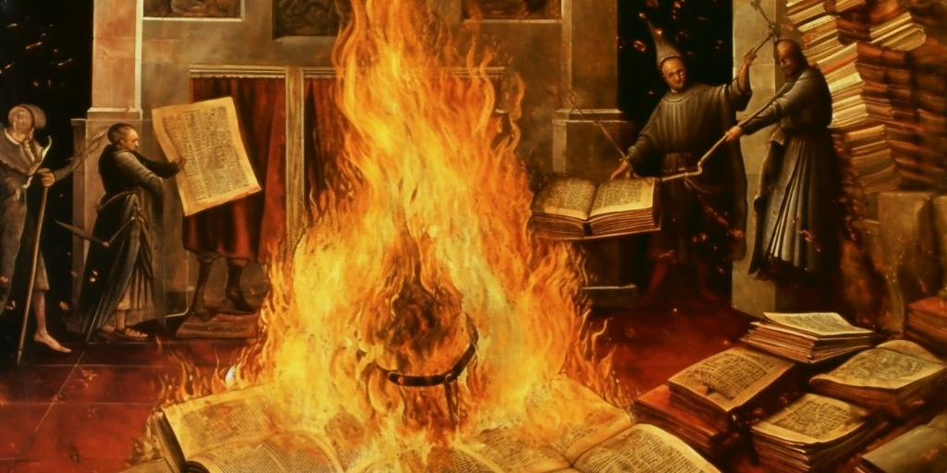

Some famous incidents include Nicholas Donin, a Jewish apostate, disputing R’ Yechiel of Paris in 1240 that resulted in the burning of 24 wagonloads of hand-written volumes of Talmud. In 1263, King James I of Spain ordered the Ramban to debate with apostate Pablo Christiani at a disputation in Barcelona. In the 15th century, R’ Yosef Albo participated in the disputation of Tortosa. In 1757 in Kamenets, Polish Jewry was tasked with defending Judaism and the Talmud against Jacob Frank that included the spurious blood libel charge, the false accusation that Jews baked their matzahs with the blood of murdered Christian babies. The list sadly goes on and on.
The more things change, the more they stay the same. Who would believe that in 2024, public personalities with large platforms could continue to shamelessly promote blood libels and unfounded accusations about the Talmud to an audience eager to hear it.
The response to my post was predictable, but it was nonetheless jarring. A torrent of antisemitism, including hundreds of hateful comments, were unleashed in my direction. A small sample of some of the ones I can print here:
“The only lighting up the Talmud should do is when it’s drenched in gasoline and set fire to.”
“Nicholas Donin was a hero”
“The Talmud is satanic garbage”
An educator named Rabbi Yisrael M. Eliashiv wrote a detailed thread addressing each of the alleged Talmudic statements, finding and posting original sources, and debunking the lies in the offensive image. He introduced it by saying, “Preface: None of this is new; most of these fake quotes originate from a couple of antisemitic German books that are over a hundred years old and they've been debunked over and over in many places. Sadly, most of them are not so accessible so I'll go over them myself.”
Impressively, the response has been viewed 2.1 million times. While it does set the record straight for those who are willing to read it and be open to the truth, sadly, that number is less than half of the number who read the original, hateful post.

Get Informed
The Jewish people are under attack. We are the target of false accusations and distortions of our Torah, of our country, and of our people. Ignorance is not bliss, it is irresponsible. How can we expect others to defend us if we are unaware and unfamiliar with the facts and truths ourselves? We may well encounter a hateful antisemite, or even someone well-intentioned who came across a post that made them question what we believe, who saw something that makes them ask us about our sacred texts.
When the moment arises at the watercooler at work, on the checkout line of the supermarket, or with our seatmate on the plane, will we be ready, armed and informed with the facts? Are our children sufficiently literate on the basics of our people, our history, our Torah, and Israel to stand up and defend if they are ever under attack?
Our rabbis teach: “Rebbe Elazar said: Be diligent in the study of the Torah and know how to answer a heretic” (Ethics of the Fathers, 2:14).
Commentators wonder, why doesn’t Rebbe Elazar command us to answer the disputer; why is the instruction “know what to answer”?
If they are looking into the Talmud to discredit it, we must be inspired to look more often and more deeply into our Talmud to be informed, inspired and guided by it.
The greatest response to our enemies and attackers is not necessarily to engage and debate but to be knowledgeable, literate, informed, passionate and practicing. That is why the Mishna begins by telling us to be diligent in studying Torah. How much? Until you are armed with the knowledge, confidence, and clarity to not be threatened or challenged by the heretic and instead to live a passionate, rich Jewish life.
Just like the antagonists and disputants who came before, Dan Bilzerian, Candace Owens and the raging antisemites of our time will not be effective and will not be remembered, but our sacred Torah and our timeless Talmud will continue to be learned around the world.

We Must Be Inspired to Look More
Often and More Deeply into Our Talmud
If they are looking into the Talmud to discredit it, we must be inspired to look more often and more deeply into our Talmud to be informed, inspired and guided by it.
We must continue to confront and stop antisemites, but the most important response we can offer is to not only never apologize, be ashamed or defensive of our Talmud or tradition, but to channel their hate into a greater love and commitment for our wisdom and our way of life.
They want us to stop learning and living Torah? The response must be to learn it and live it more.
They want us to abandon our values? Lean into them, hold on to them stronger, tighter.
They want you to hide your yarmulka? Get a bigger one.

We Must Become a Better, Bigger
and More Practicing and Learned Jew
We cannot win if we don’t know what we are fighting for. Become a better, bigger, and more practicing and learned Jew.
Someone asked me, if I had $100 million to fight antisemitism what would I do? I said I wouldn’t buy ads on television or hire lobbyists in Congress. I would put every penny into reaching out to our Jewish brothers and sisters to stand taller, prouder, to live more Jewishly. I would send a mezuzah for every Jew and every Jewish student on a college campus to hang on their door. I would send candles for every Jew to light Friday night or for Hanukkah.
We cannot win if we don’t know what we are fighting for. Become a better, bigger, and more practicing and learned Jew.

Reprinted from the current website of aish.com

